COAL LAB # 05
SUBMITTED TO: MAM REHANA
SUBMITTED BY: Faiqa Rafique
SAP ID: 72027
DATE: 15 SEP, 2026
TASK 01:
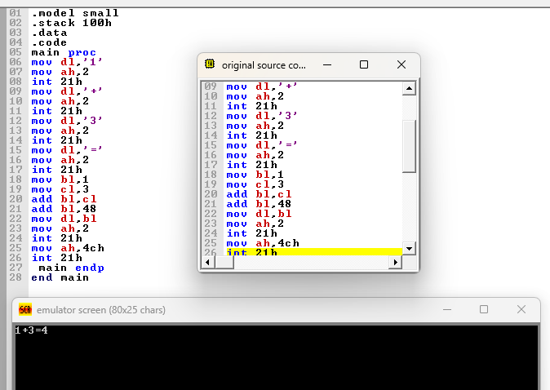
TASK 02: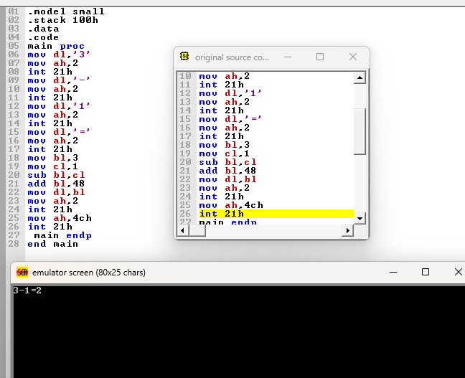

TASK 03:

